11.Create a dataframe of ten rows, four columns with random values. Convert some values to nan values. Write a Pandas program which will highlight the nan values.
Aim:
To create a DataFrame of 10 rows and 4 columns with random values, convert some values to NaN, and highlight the NaN values.
Program:
import pandas as pd
import numpy as np

data = pd.DataFrame(
np.random.randint(1, 100, size=(10, 4)),
columns=["A", "B", "C", "D"]
)

data.iloc[1, 2] = np.nan
data.iloc[4, 0] = np.nan
data.iloc[7, 3] = np.nan

def highlight_nan(val):
if pd.isna(val):
return "background-color: yellow"
return ""

styled = data.style.map(highlight_nan)

print(data)

styled

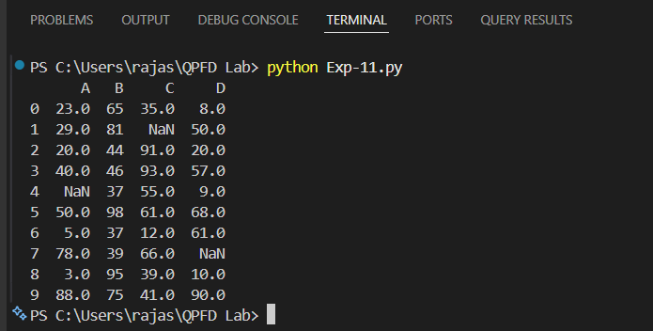
Output:
Result:
The program successfully created a DataFrame, converted some values to NaN, and highlighted the NaN values.

12.Create a dataframe of ten rows, four columns with random values. Write a Pandas
program to set dataframe background Color black and font color yellow.
Aim:
To create a DataFrame of 10 rows and 4 columns with random values and set the DataFrame background color to black and font color to yellow.
Program:
import pandas as pd
import numpy as np

data = pd.DataFrame(
np.random.randint(1, 100, size=(10, 4)),
columns=["A", "B", "C", "D"]
)

styled = data.style.set_properties(**{
"background-color": "black",
"color": "yellow"
})

print(data)

styled
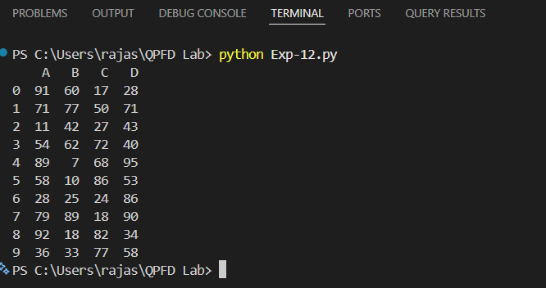
Output:
Result:
The program successfully created a DataFrame with random values and displayed it with a black background and yellow font color.

